**An American Revolution in Art: Review Questions:**

1. What was the economic center of America in 1730? Why did artists work in these wealthier areas?
2. Before American art schools were established, where did Americans study art?
3. Who was the first professionally trained painter to start their career in America? (He also has a shop where he sells art materials and offers art lessons)

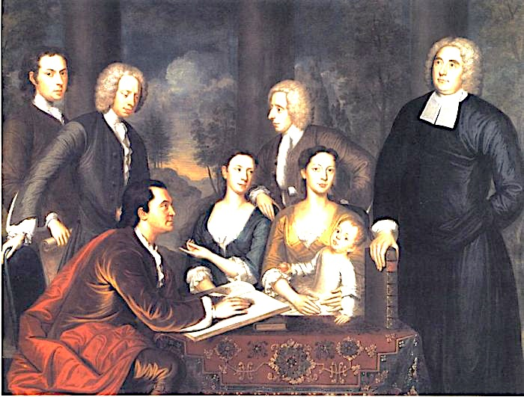

1. How can you tell the artist included himself in this painting (above)?
2. Describe REALISM:
3. Who was the first artist to prosper financially in America? (He was Irish)
4. What type of people did he typically depict in his artwork?
5. Who was the silversmith Copley depicted in a painting in 1768 (below)?

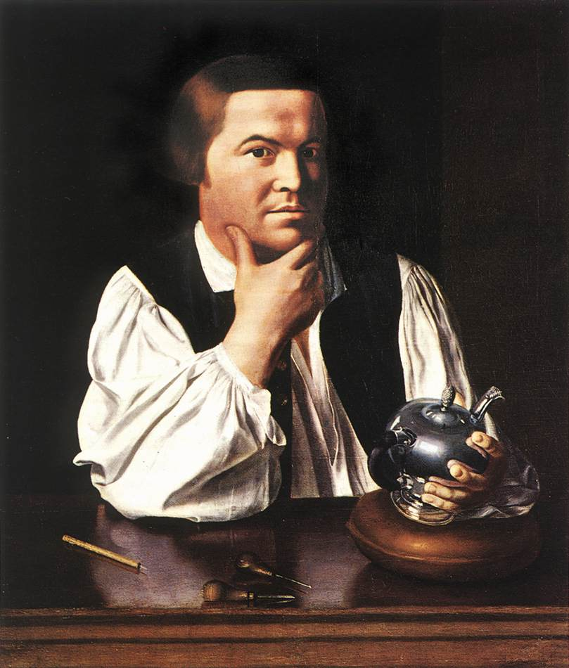

1. Which artist had artwork that was placed on the $2 bill?
2. What was the scene depicted on the $2 bill (below)?

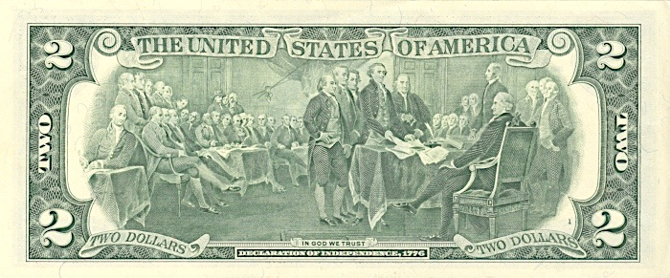

1. Why was Benjamin West considered the “American Raphael?
2. Describe symbolism:
3. Name three symbolic images/aspects of Benjamin West’s “The Death of General Wolf”:

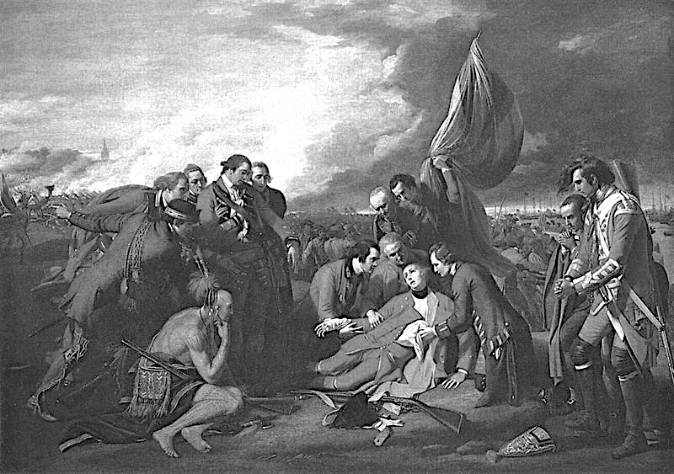

1. Who started “The American School”? Where is it located?
2. Who opens America’s first public museum? Where is it located?
3. Who’s famous portrait was hung on the wall of many American households during the Revolutionary era?

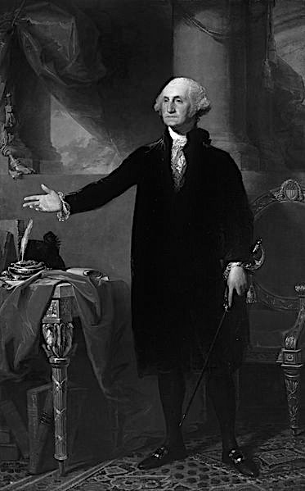

17. Who was the first African American professional Artist?